canvas-Beispiele (canvas = Leinwand) (wir zeichnen)
canvas1.html
<html>
<head>
<title>Rechteck mit Diagonale</title>
</head>
<body>
<canvas id="canvas1" width="600px" height="400px"></canvas>
<script>
function draw()
{
var canvas = document.getElementById("canvas1");

if (canvas.getContext)
{
var context = canvas.getContext("2d");

context.beginPath();
context.moveTo(0, 0);
context.strokeStyle = "#f00";
context.lineWidth = 2;
context.lineTo(598, 398);
context.closePath();
context.stroke();

context.strokeStyle = "#0f0";
context.lineWidth = 2;
context.strokeRect(1, 1, 598, 398);
}
}
window.onload = function(){
draw();
}
</script>
</body>
</html>

Output ⇨
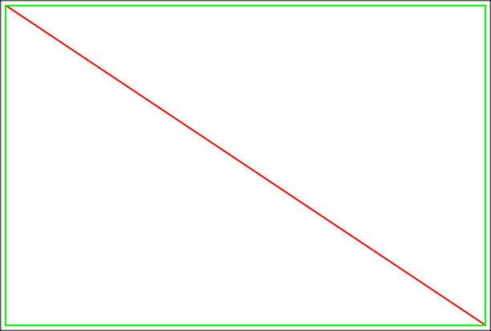
canvas2.html
<html>
<head>
<title>Rechteck schwarz/weiß</title>
</head>
<body>
<canvas id="canvas1" width="600px" height="400px"></canvas>
<script>
function draw()
{
var canvas = document.getElementById("canvas1");

if (canvas.getContext)
{
var context = canvas.getContext("2d");

context.beginPath();
context.moveTo(1, 1);
context.strokeStyle = "#000";
context.lineWidth = 2;
context.lineTo(590, 398);
context.lineTo(1, 398);
context.closePath();
context.stroke();

context.beginPath();
context.moveTo(598, 0);
context.fillStyle = "#000";
context.lineWidth = 2;
context.lineTo(8, 0);
context.lineTo(598, 398);
context.closePath();
context.fill();
}
}
window.onload = function() {
draw();
}
</script>
</body>
</html>

Output ⇨
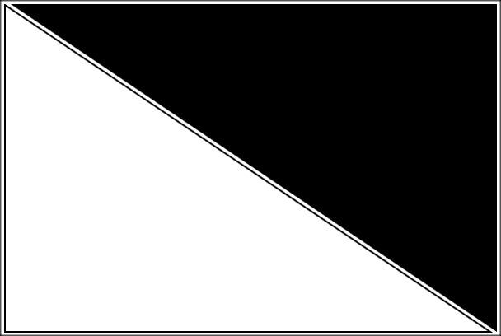
canvas3.html
<html>
<head>
<title>Herz</title>
</head>
<body>
<canvas id="canvas1" width="600px" height="400px"></canvas>
<script>
function draw()
{
var canvas = document.getElementById("canvas1");

if (canvas.getContext)
{
var context = canvas.getContext("2d");

context.beginPath();
context.moveTo(75,40);
context.bezierCurveTo(75,37,70,25,50,25);
context.bezierCurveTo(20,25,20,62.5,20,62.5);
context.bezierCurveTo(20,80,40,102,75,120);
context.bezierCurveTo(110,102,130,80,130,62.5);
context.bezierCurveTo(130,62.5,130,25,100,25);
context.bezierCurveTo(85,25,75,37,75,40);
context.fill();
}
}
window.onload = function(){
draw();
}
</script>
</body>
</html>

Output ⇨

canvas4.html
<html>
<head>
<title>Testbild</title>
</head>
<body>
<canvas id="canvas1" width="640px" height="400px"></canvas>
<script>
function draw()
{
var image = new Image();

image.onload = function()
{
var canvas = document.getElementById("canvas1");

if (canvas.getContext)
{
var context = canvas.getContext("2d");

for (var i=0;i < 10;i++)
{
for (var j=0;j < 4;j++)
{
context.drawImage(image, i * 64, j * 56);
}
}
}
}
image.src = "Testbild.png";
}
window.onload = function() {
draw();
}
</script>
</body>
</html>

Output ⇨
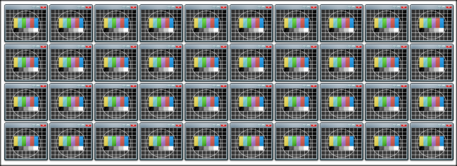
canvas5.html
<html>
<head>
<title>Testbild</title>
</head>
<body>
<canvas id="canvas1" width="640px" height="400px"></canvas>
<script>
var currentIndex = 0;
var image = new Image();

function draw()
{
image.onload = function()
{
startAnimation();
}
image.src = "Testbild.png";
}

window.onload = function() {
draw();
}

function startAnimation()
{
var canvas = document.getElementById("canvas1");

if (canvas.getContext)
{
var context = canvas.getContext("2d");

context.translate(250, 150);
runAnimation();
}
}

function runAnimation()
{
var canvas = document.getElementById("canvas1");

if (canvas.getContext)
{
var context = canvas.getContext("2d");

context.save();
context.rotate(currentIndex * Math.PI / 16);
context.drawImage(image, 30, 0);
context.restore();

currentIndex++;
if (currentIndex >= 32)
currentIndex = 0;
setTimeout(runAnimation, 50);
}
}
</script>
</body>
</html>
Output ⇨ (Animation)
