**canvas-Beispiele** (**canvas** = Leinwand) (wir zeichnen)

**canvas1.html**

<html>

<head>

<title>Rechteck mit Diagonale</title>

</head>

<body>

<**canvas** id="canvas1" width="600px" height="400px"><**/canvas**>

<script>

**function draw()**

{

var canvas = document.getElementById("canvas1");

if (canvas.getContext)

{

var context = canvas.getContext("2d");

context.beginPath();

context.moveTo(0, 0);

context.strokeStyle = "#f00";

context.lineWidth = 2;

context.lineTo(598, 398);

context.closePath();

context.stroke();

context.strokeStyle = "#0f0";

context.lineWidth = 2;

context.strokeRect(1, 1, 598, 398);

}

}

window.onload = function(){

draw();

}

</script>

</body>

</html>

**Output ⇨**

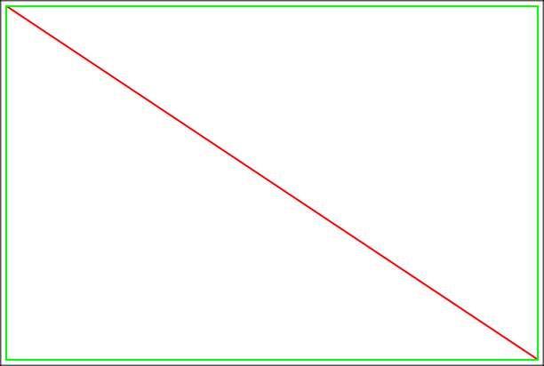

**canvas2.html**

<html>

<head>

<title>Rechteck schwarz/weiß</title>

</head>

<body>

<**canvas** id="canvas1" width="600px" height="400px"><**/canvas**>

<script>

**function draw()**

{

var canvas = document.getElementById("canvas1");

if (canvas.getContext)

{

var context = canvas.getContext("2d");

context.beginPath();

context.moveTo(1, 1);

context.strokeStyle = "#000";

context.lineWidth = 2;

context.lineTo(590, 398);

context.lineTo(1, 398);

context.closePath();

context.stroke();

context.beginPath();

context.moveTo(598, 0);

context.fillStyle = "#000";

context.lineWidth = 2;

context.lineTo(8, 0);

context.lineTo(598, 398);

context.closePath();

context.fill();

}

}

window.onload = function() {

draw();

}

</script>

</body>

</html>

**Output ⇨**

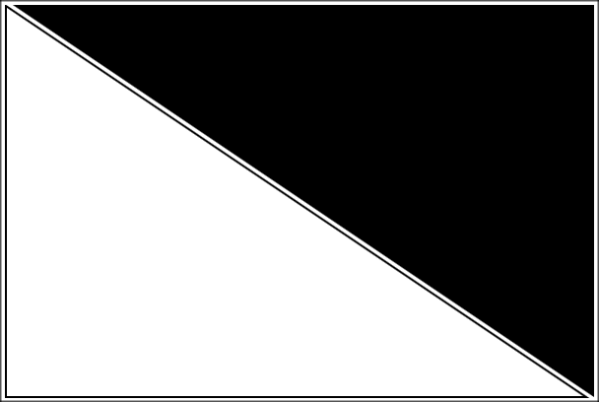

**canvas3.html**

<html>

<head>

<title>Herz</title>

</head>

<body>

<**canvas** id="canvas1" width="600px" height="400px"><**/canvas**>

<script>

**function draw()**

{

var canvas = document.getElementById("canvas1");

if (canvas.getContext)

{

var context = canvas.getContext("2d");

context.beginPath();

context.moveTo(75,40);

context.bezierCurveTo(75,37,70,25,50,25);

context.bezierCurveTo(20,25,20,62.5,20,62.5);

context.bezierCurveTo(20,80,40,102,75,120);

context.bezierCurveTo(110,102,130,80,130,62.5);

context.bezierCurveTo(130,62.5,130,25,100,25);

context.bezierCurveTo(85,25,75,37,75,40);

context.fill();

}

}

window.onload = function(){

draw();

}

</script>

</body>

</html>

**Output ⇨**



**canvas4.html**

<html>

<head>

<title>Testbild</title>

</head>

<body>

<**canvas** id="canvas1" width="640px" height="400px"><**/canvas**>

<script>

**function draw()**

{

var image = new Image();

image.onload = function()

{

var canvas = document.getElementById("canvas1");

if (canvas.getContext)

{

var context = canvas.getContext("2d");

for (var i=0;i < 10;i++)

{

for (var j=0;j < 4;j++)

{

context.drawImage(image, i * 64, j * 56);

}

}

}

}

image.src = "Testbild.png";

}

window.onload = function() {

draw();

}

</script>

</body>

</html>

**Output ⇨**

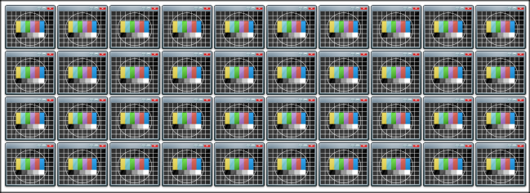

**canvas5.html**

<html>

<head>

<title>Testbild</title>

</head>

<body>

<canvas id="canvas1" width="640px" height="400px"></canvas>

<script>

var currentIndex = 0;

var image = new Image();

function draw()

{

image.onload = function()

{

startAnimation();

}

image.src = "Testbild.png";

}

window.onload = function() {

draw();

}

function startAnimation()

{

var canvas = document.getElementById("canvas1");

if (canvas.getContext)

{

var context = canvas.getContext("2d");

context.translate(250, 150);

runAnimation();

}

}

function runAnimation()

{

var canvas = document.getElementById("canvas1");

if (canvas.getContext)

{

var context = canvas.getContext("2d");

context.save();

context.rotate(currentIndex * Math.PI / 16);

context.drawImage(image, 30, 0);

context.restore();

currentIndex++;

if (currentIndex >= 32)

currentIndex = 0;

setTimeout(runAnimation, 50);

}

}

</script>

</body>

</html>

**Output ⇨** (Animation)

