**canvas_clock-01.html**

<!DOCTYPE html>

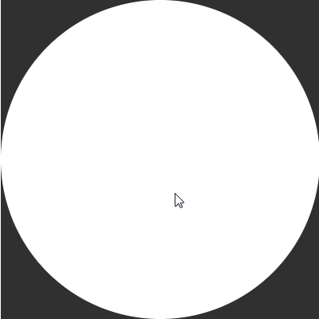<html>

<body>

<canvas id="canvas" width="400" height="400"

style="background-color:#333">

</canvas>

<script>

var canvas = document.getElementById("canvas");

var ctx = canvas.getContext("2d");

var radius = canvas.height / 2;

ctx.translate(radius, radius);

drawClock();

**function drawClock()**

{

ctx.arc(0, 0, radius, 0 , 2*Math.PI);

ctx.fillStyle = "white";

ctx.fill();

}

</script>

</body>

</html>

**canvas_clock-02.html**

<!DOCTYPE html>

<html>

<body>

<canvas id="canvas" width="400" height="400"

style="background-color:#333">

</canvas>

<script>

var canvas = document.getElementById("canvas");

var ctx = canvas.getContext("2d");

var radius = canvas.height / 2;

ctx.translate(radius, radius);

drawClock();

**function drawClock()**

{

drawFace(ctx, radius);

}

**function drawFace(ctx, radius)**

{

var grad;

ctx.beginPath();

ctx.arc(0, 0, radius, 0, 2 * Math.PI);

ctx.fillStyle = 'white';

ctx.fill();

grad = ctx.createRadialGradient(0, 0, radius * 0.95, 0, 0, radius * 1.05);

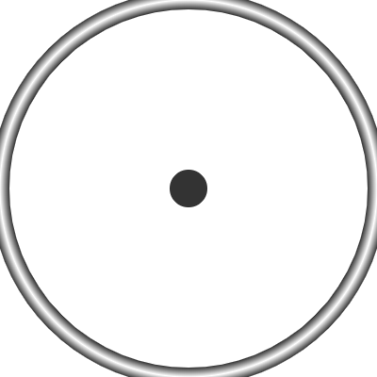 grad.addColorStop(0, '#333');

grad.addColorStop(0.5, 'white');

grad.addColorStop(1, '#333');

ctx.strokeStyle = grad;

ctx.lineWidth = radius * 0.1;

ctx.stroke();

ctx.beginPath();

ctx.arc(0, 0, radius*0.1, 0, 2 * Math.PI);

ctx.fillStyle = '#333';

ctx.fill();

}

</script>

</body>

</html>

**canvas_clock-03.html**

<!DOCTYPE html>

<html>

<body>

<canvas id="canvas" width="400" height="400"

style="background-color:#333">

</canvas>

<script>

var canvas = document.getElementById("canvas");

var ctx = canvas.getContext("2d");

var radius = canvas.height / 2;

ctx.translate(radius, radius);

drawClock();

**function drawClock()**

{

drawFace(ctx, radius);

drawNumbers(ctx, radius);

}

**function drawFace(ctx, radius)**

{

var grad;

ctx.beginPath();

ctx.arc(0, 0, radius, 0, 2 * Math.PI);

ctx.fillStyle = 'white';

ctx.fill();

grad = ctx.createRadialGradient(0, 0, radius * 0.95, 0, 0, radius * 1.05);

grad.addColorStop(0, '#333');

grad.addColorStop(0.5, 'white');

grad.addColorStop(1, '#333');

ctx.strokeStyle = grad;

ctx.lineWidth = radius * 0.1;

ctx.stroke();

ctx.beginPath();

ctx.arc(0, 0, radius*0.1, 0, 2 * Math.PI);

ctx.fillStyle = '#333';

ctx.fill();

}

**function drawNumbers(ctx, radius)**

{

var ang;

var num;

ctx.font = radius * 0.15 + "px arial";

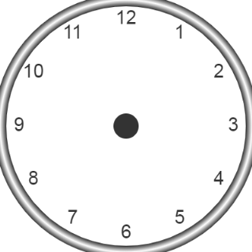 ctx.textBaseline = "middle";

ctx.textAlign = "center";

for (num = 1;num < 13;num++)

{

ang = num * Math.PI / 6;

ctx.rotate(ang);

ctx.translate(0, -radius * 0.85);

ctx.rotate(-ang);

ctx.fillText(num.toString(), 0, 0);

ctx.rotate(ang);

ctx.translate(0, radius * 0.85);

ctx.rotate(-ang);

}

}

</script>

</body>

</html>

**canvas_clock-04.html**

<!DOCTYPE html>

<html>

<body>

<canvas id="canvas" width="400" height="400"

style="background-color:#333">

</canvas>

<script>

var canvas = document.getElementById("canvas");

var ctx = canvas.getContext("2d");

var radius = canvas.height / 2;

ctx.translate(radius, radius);

radius = radius * 0.90

drawClock();

**function drawClock()**

{

drawFace(ctx, radius);

drawNumbers(ctx, radius);

drawTime(ctx, radius);

}

**function drawFace(ctx, radius)**

{

var grad;

ctx.beginPath();

ctx.arc(0, 0, radius, 0, 2 * Math.PI);

ctx.fillStyle = 'white';

ctx.fill();

grad = ctx.createRadialGradient(0, 0, radius * 0.95, 0, 0, radius * 1.05);

grad.addColorStop(0, '#333');

grad.addColorStop(0.5, 'white');

grad.addColorStop(1, '#333');

ctx.strokeStyle = grad;

ctx.lineWidth = radius * 0.1;

ctx.stroke();

ctx.beginPath();

ctx.arc(0, 0, radius*0.1, 0, 2 * Math.PI);

ctx.fillStyle = '#333';

ctx.fill();

}

**function drawNumbers(ctx, radius)**

{

var ang;

var num;

ctx.font = radius * 0.15 + "px arial";

ctx.textBaseline = "middle";

ctx.textAlign = "center";

for (num = 1;num < 13;num++)

{

ang = num * Math.PI / 6;

ctx.rotate(ang);

ctx.translate(0, -radius * 0.85);

ctx.rotate(-ang);

ctx.fillText(num.toString(), 0, 0);

ctx.rotate(ang);

ctx.translate(0, radius * 0.85);

ctx.rotate(-ang);

}

}

**function drawTime(ctx, radius)**

{

var now = new Date();

var hour = now.getHours();

var minute = now.getMinutes();

var second = now.getSeconds();

**// hour**

hour = hour % 12;

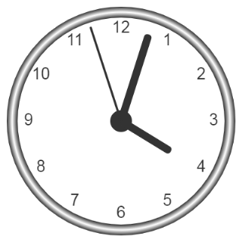 hour = (hour * Math.PI / 6) +

(minute * Math.PI / ( 6 * 60)) +

(second * Math.PI / (360 * 60));

drawHand(ctx, hour, radius * 0.5, radius * 0.07);

**// minute**

minute = (minute * Math.PI / 30) + (second * Math.PI / (30 * 60));

drawHand(ctx, minute, radius * 0.8, radius * 0.07);

**// second**

second = (second * Math.PI/30);

drawHand(ctx, second, radius * 0.9, radius * 0.02);

}

**function drawHand(ctx, pos, length, width)**

{

ctx.beginPath();

ctx.lineWidth = width;

ctx.lineCap = "round";

ctx.moveTo(0,0);

ctx.rotate(pos);

ctx.lineTo(0, -length);

ctx.stroke();

ctx.rotate(-pos);

}

</script>

</body>

</html>

**canvas_clock-05.html**

<!DOCTYPE html>

<html>

<body>

<canvas id="canvas" width="400" height="400"

style="background-color:#333">

</canvas>

<script>

var canvas = document.getElementById("canvas");

var ctx = canvas.getContext("2d");

var radius = canvas.height / 2;

ctx.translate(radius, radius);

radius = radius * 0.90

**setInterval(drawClock, 1000);**

**function drawClock()**

{

drawFace(ctx, radius);

drawNumbers(ctx, radius);

drawTime(ctx, radius);

}

**function drawFace(ctx, radius)**

{

var grad;

ctx.beginPath();

ctx.arc(0, 0, radius, 0, 2*Math.PI);

ctx.fillStyle = 'white';

ctx.fill();

grad = ctx.createRadialGradient(0,0,radius*0.95, 0,0,radius*1.05);

grad.addColorStop(0, '#333');

grad.addColorStop(0.5, 'white');

grad.addColorStop(1, '#333');

ctx.strokeStyle = grad;

ctx.lineWidth = radius*0.1;

ctx.stroke();

ctx.beginPath();

ctx.arc(0, 0, radius*0.1, 0, 2*Math.PI);

ctx.fillStyle = '#333';

ctx.fill();

}

**function drawNumbers(ctx, radius)**

{

var ang;

var num;

ctx.font = radius*0.15 + "px arial";

ctx.textBaseline="middle";

ctx.textAlign="center";

for(num = 1; num < 13; num++){

ang = num * Math.PI / 6;

ctx.rotate(ang);

ctx.translate(0, -radius*0.85);

ctx.rotate(-ang);

ctx.fillText(num.toString(), 0, 0);

ctx.rotate(ang);

ctx.translate(0, radius*0.85);

ctx.rotate(-ang);

}

}

**function drawTime(ctx, radius)**

{

var now = new Date();

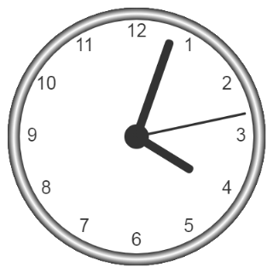 var hour = now.getHours();

var minute = now.getMinutes();

var second = now.getSeconds();

**// hour**

hour=hour%12;

hour=(hour*Math.PI/6)+

(minute*Math.PI/(6*60))+

(second*Math.PI/(360*60));

drawHand(ctx, hour, radius*0.5, radius*0.07);

**// minute**

minute=(minute*Math.PI/30)+(second*Math.PI/(30*60));

drawHand(ctx, minute, radius*0.8, radius*0.07);

**// second**

second=(second*Math.PI/30);

drawHand(ctx, second, radius*0.9, radius*0.02);

}

**function drawHand(ctx, pos, length, width)**

{

ctx.beginPath();

ctx.lineWidth = width;

ctx.lineCap = "round";

ctx.moveTo(0,0);

ctx.rotate(pos);

ctx.lineTo(0, -length);

ctx.stroke();

ctx.rotate(-pos);

}

</script>

</body>

</html>