**Tabellen-Grundstruktur Darstellung.html**

<!DOCTYPE html>

<html lang="de">

<head>

<title>Tabelle - Grundstruktur</title>

<meta charset="utf-8">

</head>

<body bgcolor = "white">

<table border = "1" cellpadding = "5" cellspacing = "0">

<td>links oben</td>

<td>rechts oben</td>

<tr>

<td>links unten</td>

<td>rechts unten</td>

</table>

</body>

</html>

**Output ⇨**

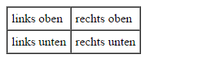

**Tabelle mit COLSPAN.html**

<!DOCTYPE html>

<html lang="de">

<head>

<title>Tabelle - Grundstruktur</title>

<meta charset="utf-8">

</head>

<body bgcolor = "white">

<table border = "1" cellspacing = "0" cellpadding = "10">

<td colspan = "2">11 und 12</td>

<td>12</td>

<tr>

<td>21</td>

<td>22</td>

<td>23</td>

</table>

</body>

</html>

**Output ⇨**

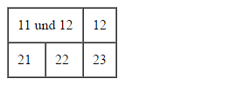

**Tabelle mit ROWSPAN.html**

<!DOCTYPE html>

<html lang="de">

<head>

<title>Tabelle - Grundstruktur</title>

<meta charset="utf-8">

</head>

<body bgcolor = "white">

<table border = "1" cellspacing = "0" cellpadding = "10">

<td>11</td>

<td>12</td>

<TR>

<td>21</td>

<td rowspan = "2">22 und 32</td>

<TR>

<td>31</td>

</table>

</body>

</html>

**Output ⇨**

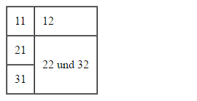

**Tabelle mit ROWSPAN und COLSPAN.html**

<!DOCTYPE html>

<html lang="de">

<head>

<title>Tabelle - Grundstruktur</title>

<meta charset="utf-8">

</head>

<body bgcolor = "white">

<table border = "1" cellspacing = "0" cellpadding = "10">

<td colspan = "2">11 und 12</td>

<td>12</td>

<tr>

<td>21</td>

<td rowspan = "2">22 und 32</td>

<td>99</td>

</table>

</body>

</html>

**Output ⇨**

