Vokabeltrainer (vokabeln.html)
<!DOCTYPE html>
<html>
<head>
<script>
var n = -1;
var frage = new Array();
var antwort = new Array();

frage[0] = "Tisch";
antwort[0] = "table";

frage[1] = "Stuhl";
antwort[1] = "chair";

frage[2] = "Tafel";
antwort[2] = "black board";

frage[3] = "Kreide";
antwort[3] = "chock";

frage[4] = "Löffel";
antwort[4] = "spoon";

function abfrage()
{
n++;
document.Formular.ausgabe.value = frage[n];
document.Formular.eingabe.value = "";
document.Formular.kontrolle.value = "";
}

function pruefe()
{
if (document.Formular.eingabe.value == antwort[n])
{
document.Formular.kontrolle.value = "richtig";
}
else
{
document.Formular.kontrolle.value = " falsch, richtig wäre: " + antwort[n];
}
}
</script>
</head>

<body>
<form name = "Formular">
<input type = "button" name = "Knopf1" value = "Weiter" onClick = "abfrage()">
<input type = "button" name = "Knopf2" value = "Kontrolle" onClick = "pruefe()"> <br>
<input type = "text" name = "ausgabe" size = "80"> <br>
<input type = "text" name = "eingabe" size = "80"> <br>
<input type = "text" name = "kontrolle" size = "80">
</form>
</body>
</html>

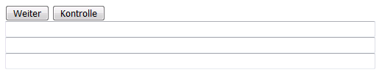 |  | 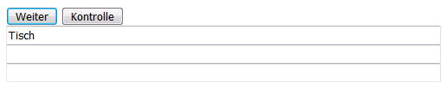
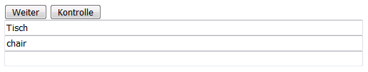 |  | 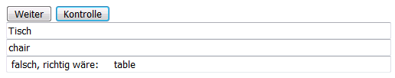
 |  | 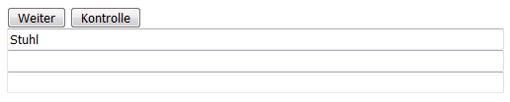
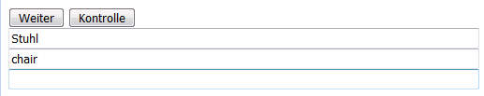 |  | 