**<!DOCTYPE html>**

**<html** **lang**=**"de">**

**<head>** **<title>**Tabelle - Stundenplan**</title>**

**<meta** **charset**=**"utf-8">**

**</head>**

**<body** **bgcolor**=**"white">**

**<table** **border**=**"1"** **cellpadding**=**"10"** **cellspacing**=**"0">**

**<th** **colspan**=**"6">**Stundenplan**</th><!-- Überschrift -->**

**<tr><!-- Zeiten + Wochentage -->**

**<th>**Zeiten**</th>**

**<th>**Montag**</th>**

**<th>**Dienstag**</th>**

**<th>**Mittwoch**</th>**

**<th>**Donnerstag**</th>**

**<th>**Freitag**</th>**

**</tr>**

**<tr><!-- 1. Stunde -->**

**<td>**08:00 - 09:00**</td>**

**<td>**WP1**</td>**

**<td>**Englisch**</td>**

**<td>**WP1 (frei)**</td>**

**<td>**GL**</td>**

**<td>**Ma**th**e**</td>**

**</tr>**

**<tr><!-- 2. Stunde -->**

**<td>**09:05 - 10:05**</td>**

**<td>**Deutsch**</td>**

**<td>**Religion**</td>**

**<td>**WP1**</td>**

**<td>**Biologie**</td>**

**<td>**Physik**</td>**

**</tr>**

**<tr><!-- 1. Pause -->**

**<td></td>**

**<td** **colspan**=**"5"><center>**Pause**<br>**10:05 - 10:35**</center></td>**

**</tr>**

**<tr><!-- 3. Stunde -->**

**<td>**10:35 - 11:35**</td>**

**<td>**Musik**</td>**

**<td>**Sport**</td>**

**<td>**Ma**th**e**</td>**

**<td>**ERG (Informatik)**</td>**

**<td>**Englisch**</td>**

**</tr>**

**<tr><!-- 4. Stunde -->**

**<td>**11:40 - 12:40**</td>**

**<td>**Chemie**</td>**

**<td>**Ma**th**e**</td>**

**<td>**Englisch**</td>**

**<td>**Deutsch**</td>**

**<td>**Deutsch**</td>**

**</tr>**

**<tr><!-- 2. Pause -->**

**<td></td>**

**<td><center>**Mittagspause**<br>**12:40 - 13:40**</center></td>**

**<td><center>**Pause**<br>**12:40 - 12:55**</center></td>**

**<td** **colspan**=**"2"><center>**Mittagspause**<br>**12:40 - 13:40**</center></td>**

**<td><center>**Pause**<br>**12:40 - 12:55**</center></td>**

**</tr>**

**<tr><!-- 5. Stunde (an kurzen Tagen) -->**

**<td>**12:55 - 13:50**</td>**

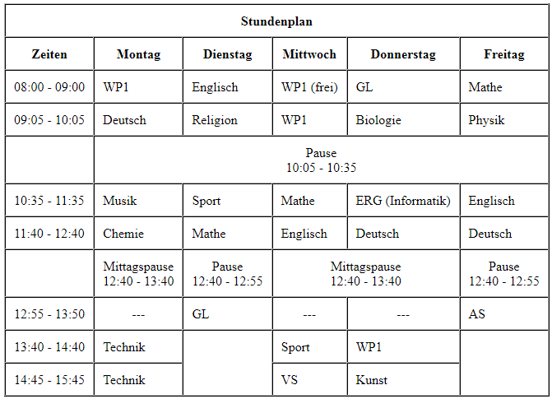 **<td><center>**---**</center></td>**

**<td>**GL**</td>**

**<td><center>**---**</center></td>**

**<td><center>**---**</center></td>**

**<td>**AS**</td>**

**</tr>**

**<tr><!-- 5. Stunde (regulär) -->**

**<td>**13:40 - 14:40**</td>**

**<td>**Technik**</td>**

**<td** **rowspan**=**"2"></td>**

**<td>**Sport**</td>**

**<td>**WP1**</td>**

**<td** **rowspan**=**"2"></td>**

**</tr>**

**<tr><!-- 6. Stunde -->**

**<td>**14:45 - 15:45**</td>**

**<td>**Technik**</td>**

**<td>**VS**</td>**

**<td>**Kunst**</td>**

**</tr>**

**</table>**

**</body>**

**</html>**

**<!DOCTYPE html>**

**<html** **lang**=**"de">**

**<head>**

**<title>**Tabelle – Stundenplan mit CSS**</title>**

**<meta** **charset**=**"utf-8">**

**</head>**

**<body** **bgcolor**=**"white">**

**<style>**

**.table**

{

font-size : 24px;

font-family : Arial, Helvetica, sans-serif;

background-color: white;

}

**td**

{

text-align: center;

}

**.header**

{

font-size : 32px;

color : white;

background-color: #3b3b3b;

}

**.pause**

{

color : white;

background-color: #5e5e5e;

}

**table, th, td**

{

border: 1px solid #3b3b3b;

}

**.leer**

{

}

**.anmerkung**

{

font-size : 20px;

font-family: Arial, Helvetica, sans-serif;

}

**</style>**

**<table** **border**=**"1"** **cellpadding**=**"10"** **cellspacing**=**"0" class**=**"table">**

**<th** **colspan**=**"6" class**=**"header">**Stundenplan**</th><!-- Überschrift -->**

**<tr><!-- Spaltenbreite festlegen -->**

**<col** **width**=**"170">**

**<col** **width**=**"200">**

**<col** **width**=**"200">**

**<col** **width**=**"200">**

**<col** **width**=**"200">**

**<col** **width**=**"200">**

**<th>**Zeiten**</th><!-- Zeiten + Wochentage -->**

**<th>**Montag**</th>**

**<th>**Dienstag**</th>**

**<th>**Mittwoch**</th>**

**<th>**Donnerstag**</th>**

**<th>**Freitag**</th>**

**</tr>**

**<tr><!-- 1. Stunde -->**

**<td>**08:00 - 09:00**</td>**

**<td>**WP1**</td>**

**<td>**Englisch**</td>**

**<td>**WP1 (frei)**</td>**

**<td>**GL**</td>**

**<td>**Mathe**</td>**

**</tr>**

**<tr><!-- 2. Stunde -->**

**<td>**09:05 - 10:05**</td>**

**<td>**Deutsch**</td>**

**<td>**Religion**</td>**

**<td>**WP1**</td>**

**<td>**Biologie**</td>**

**<td>**Physik**</td>**

**</tr>**

**<tr><!-- 1. Pause -->**

**<td** **class**=**"leer"></td>**

**<td** **colspan**=**"5"** **class**=**"pause">**Pause**<br>**10:05 - 10:35**</td>**

**</tr>**

**<tr><!-- 3. Stunde -->**

**<td>**10:35 - 11:35**</td>**

**<td>**Musik**</td>**

**<td>**Sport**</td>**

**<td>**Mathe**</td>**

**<td>**ERG (Informatik)**</td>**

**<td>**Englisch**</td>**

**</tr>**

**<tr><!-- 4. Stunde -->**

**<td>**11:40 - 12:40**</td>**

**<td>**Chemie**</td>**

**<td>**Mathe**</td>**

**<td>**Englisch**</td>**

**<td>**Deutsch**</td>**

**<td>**Deutsch**</td>**

**</tr>**

**<tr><!-- 2. Pause -->**

**<td></td>**

**<td** class=**"pause">**Mittagspause<br**>**12:40 - 13:40**</td>**

**<td** class=**"pause">**Pause**<br>**12:40 - 12:55**</td>**

**<td** colspan=**"2"** class=**"pause">**Mittagspause<br**>**12:40 - 13:40**</td>**

**<td** class=**"pause">**Pause**<br>**12:40 - 12:55**</td>**

**</tr><!-- 5. Stunde (an kurzen Tagen) -->**

**<tr>**

**<td>**12:55 - 13:50**</td>**

**<td>**---**</td>**

**<td>**GL**</td>**

**<td>**---**</td>**

**<td>**---**</td>**

**<td>**AS**</td>**

**</tr>**

**<tr><!-- 5. Stunde (regulär) -->**

**<td>**13:40 - 14:40**</td>**

**<td>**Technik¹**</td>**

**<td rowspan**=**"2"** **class**=**"leer"></td>**

**<td>**Sport**</td>**

**<td>**WP1**</td>**

**<td rowspan**=**"2"** **class**="**leer"></td>**

**</tr>**

**<tr><!-- 6. Stunde -->**

**<td>**14:45 - 15:45**</td>**

**<td>**Technik¹**</td>**

**<td>**VS**</td>**

**<td>**Kunst**</td>**

**</tr>**

**</table>**

**<br>**

**<span** **class**=**"anmerkung">**¹ = Nur an geraden Kalenderwochen.**</span>**

**</body>**

**</html>**

